SECTION A. (40 marks)
- Apart from Mohair, give any other example of animal fibre.
_______________________________________________________________________
- Name any one food stuff that should be peeled before it is cooked.
_______________________________________________________________________
- Which chemical process is used to obtain ash?
_______________________________________________________________________
- Give any one importance of health surveys to the government.
_______________________________________________________________________
- Name the lens that affects the light rays as shown in the diagram below.

- Give any one activity carried out during a school health parade.
_______________________________________________________________________
- How does a hookworm enter the body of its host?
_______________________________________________________________________
- Why is carbon dioxide used in fire extinguishers?
_______________________________________________________________________
- Why is it not advisable to put sugar on a wound?
_______________________________________________________________________
- State any one danger of destroying wetlands in an area.
_______________________________________________________________________
- State any one importance of lightning conductor at school.
_______________________________________________________________________
- Name any one natural magnet.
_______________________________________________________________________

- How is peristalsis important during digestion?
_______________________________________________________________________
- How is a housefly dangerous to people?
_______________________________________________________________________
- Give one difference between an ordinary pit latrine and a water closet.
______________________________________________________________________________________________________________________________________________
- The diagram below shows two wires. Which of them has a higher electrical resistance?

a_____________________________________

b

- By what process is biogas formed from animal and plant wastes?
_______________________________________________________________________
- How do bees and plants benefit each other?
_______________________________________________________________________
- Which glands of the digestive system are responsible for producing saliva?
_______________________________________________________________________
- Besides bacteria, which other organism helps in making alcohol?
_______________________________________________________________________
- How is sound similar to heat?
_______________________________________________________________________
- Give any one way the human skin can control over heating of the body.
_______________________________________________________________________
- Name the enzyme that acts on fats in the duodenum.
_______________________________________________________________________
- How are shadow’s formed?
_______________________________________________________________________
- Give the best way of controlling the spread of HIV/AIDs among adolescents.
_______________________________________________________________________

- Why are farmers advised to grow crops and trees on the same piece of land?
_______________________________________________________________________
- Give any one pest that attacks maize in the garden.
_______________________________________________________________________
- Apart from calcium, which other mineral salt is responsible for strong bones and teeth?
_______________________________________________________________________
- How useful is a hygrometer at a weather station?
_______________________________________________________________________
- In which way is the charcoal stove made of clay able to conserve fuel?
_______________________________________________________________________
The diagram below shows the left hand side of the heart.
K
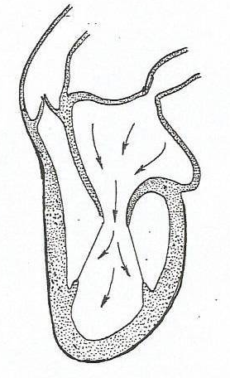
M

- State the similarity in the blood carried by vessel K and that of vessel M.
_______________________________________________________________________
- Name the gas that brings greenhouse effect on earth.
_______________________________________________________________________
- How important are fungi in the treatment of some infections?
_______________________________________________________________________
- Give any one advantage of raising seedlings in a nursery bed?
_______________________________________________________________________
- Name one example of an energy resource from fossils.
_______________________________________________________________________

- Which first aid can you give to someone who has got a scald?
_______________________________________________________________________
- Name the viral disease that makes leaves of cassava to curl and turn yellow.
_______________________________________________________________________
- Apart from pine and cedar, state any other example of a non flowering plant.
_______________________________________________________________________
- Write down the importance of ventilators in a house.
_______________________________________________________________________
- Name the lever shown below.
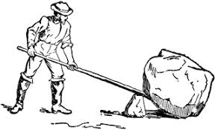

______________________________________________________________________
SECTION B.
- (a) Name any two water borne diseases.
(i)_____________________________________________________________________
(ii)____________________________________________________________________
(b)In which two ways can water borne diseases be prevented?
(i) ____________________________________________________________________
(ii)____________________________________________________________________
- (a) Give a reason why some plants climb others.
_______________________________________________________________________
(b) Identify any two methods used by plants to climb others.
(i)_____________________________________________________________________
(ii)____________________________________________________________________
(c) Mention any one plant that climbs others.
_______________________________________________________________________

- (a) Apart from evaporation, state any other two physical changes that take place in the presence of heat.
(i)_____________________________________________________________________
(ii)____________________________________________________________________
(b) State any two characteristics of physical changes.
(i)_____________________________________________________________________
(ii)____________________________________________________________________
- (a) Name any one disease that can lead to dehydration.
_______________________________________________________________________
(b) State any two ways of identifying a dehydrated person.
(i)_____________________________________________________________________
(ii)____________________________________________________________________
(c) How can dehydration be prevented among sick people?
_______________________________________________________________________
- Use the diagram below to answer questions that follow.
K

- Why is part marked k made of rings of cartilage?
_________________________________________________________________
- Name two waste products excreted by the above organ.
(i)________________________________________________________________
(ii)_______________________________________________________________
- Write down any one disease that affects the above organ.
_________________________________________________________________
- (a) What is an echo?
_______________________________________________________________________
(b) State two devices used to store sound.
(i)_____________________________________________________________________
(ii)____________________________________________________________________
(c) Give one reason for storing sound.
_______________________________________________________________________
- (a) What is swarming in bee-keeping?
_______________________________________________________________________
(b) Give any two reasons for swarming of bees.
(i)_____________________________________________________________________
(ii)____________________________________________________________________
(c) Apart from being used as food, give one other way in which honey is used by people.
_______________________________________________________________________
- (a) Write any two agents of pollination
(i)_____________________________________________________________________
(ii)____________________________________________________________________
(b) Give any two characteristics of self pollinated flowers.
(i)_____________________________________________________________________
(ii)____________________________________________________________________
- Workout the mass of Fish in the diagram below if the lever is balancing.

Fish
Meat
40kg
3m
6m

- (a) Give two diseases of cattle caused by a virus.
(i)_____________________________________________________________________
(ii)____________________________________________________________________
(b) State any one ecto-parasite in cattle.
_______________________________________________________________________
(c) How do we control ecto-parasites in cattle?
_______________________________________________________________________
- (a) Give any one permanent method of birth control in:
- Females _____________________________________________________________
- Males _______________________________________________________________
(b) Write down any two advantages of family planning.
(i) ____________________________________________________________________
(ii)____________________________________________________________________
- (a) What type of electricity is generated from running water?
_______________________________________________________________________
(b) What is the difference between solar and thermal electricity?
______________________________________________________________________________________________________________________________________________
(c) Give any two advantages of solar electricity over thermal electricity.
(i)_____________________________________________________________________
(ii)____________________________________________________________________
- (a) Give the meaning of the word soil erosion.
_______________________________________________________________________
(b) Name any two natural agents of soil erosion.
(i)_____________________________________________________________________
(ii)____________________________________________________________________
(c)How does soil erosion cause infertility in the soil?
_______________________________________________________________________

- Match the vectors in list A with the diseases they spread in list B.
A B
Water snail malaria
Housefly Trachoma
Anopheles mosquito Rabies
Mad dog Bilharzia.
A B
- Water snail ____________________________________
- Housefly ____________________________________
- Anopheles mosquito ____________________________________
- Mad dog ____________________________________
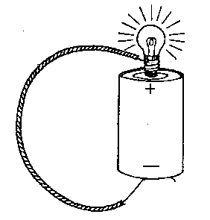
- The diagram below is of a simple circuit. Use it to answer question that follows.
P

(a)Name the part marked P.
_______________________________________________________________________
(b) Which form of energy is stored in the battery shown above?
_______________________________________________________________________
(c) State the energy change that takes place in part P when the circuit is complete.
_______________________________________________________________________
(d) Use an arrow to show the flow of current.

END.

